**Forged Coupons**

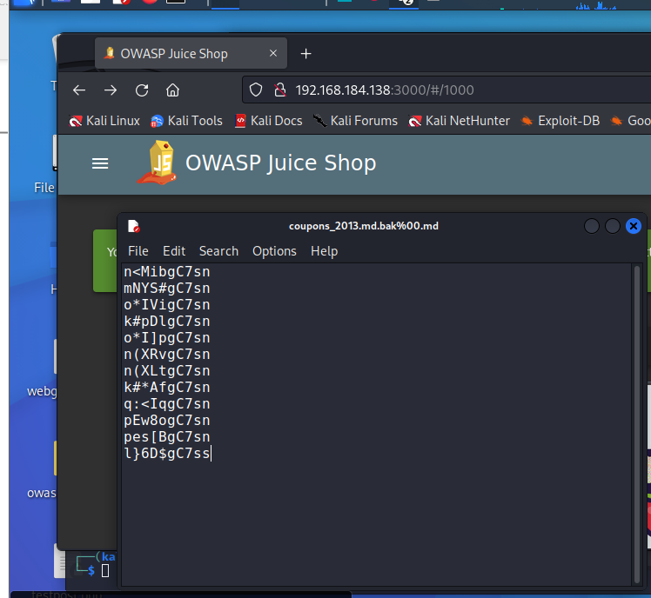

**Imaginary Challenge**

**Premium Paywall**

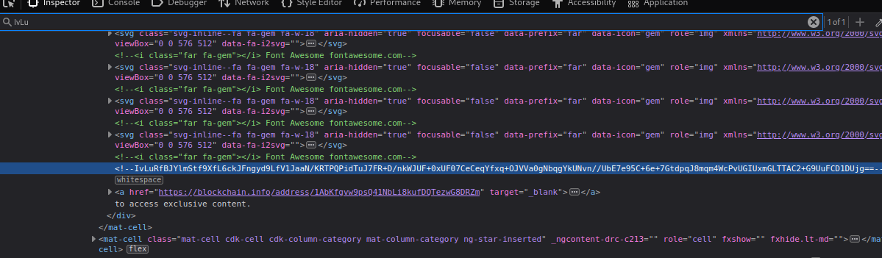

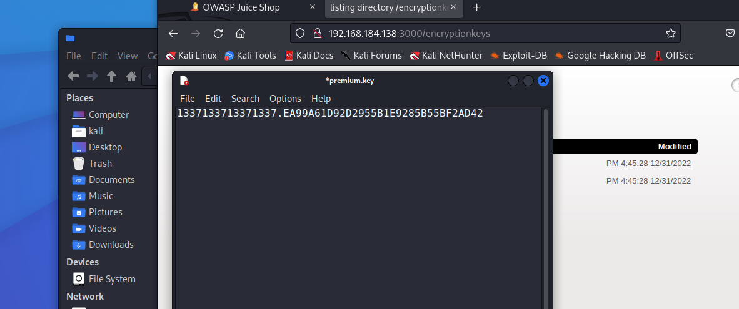

**Weird Crypto**

**Nested Easter Egg**

